

**Appendices**



**Appendix A: Email**

**Appendix A: Email Logs**

**Email Communications Log**

**DOspace Meeting Email August 25 2016**

**2016 Fall - ISQA-4110-860 : INFORMATION SYSTEMS ANALYSIS**

**(ISQA4110860.1168): Looking for group to join**

**15 messages**

**Brevan Douglas Jorgenson - bjorgenson@unomaha.edu <do-not- Thu, Aug 25, 2016 at 8:04 reply@blackboard.com> AM**

**Reply-To: "Brevan Douglas Jorgenson - bjorgenson@unomaha.edu" <bjorgenson@unomaha.edu>**

**Hello Peers,**

**My name is Brevan Jorgenson, I am currently a senior in IT Innovation major taking the ISQA 4110-860 with you. I am looking for a group to make or join, if anyone is interested please let me know. Thanks.**

**-Brevan**

**Brevan Jorgenson <bjorgenson@unomaha.edu> Thu, Aug 25, 2016 at 11:02 AM**

**To: Douglas Nichols <dnichols@unomaha.edu>, Logan Miller <loganmiller@unomaha.edu>, "Brendan M. Murray bmmurray@unomaha.edu" <bmmurray@unomaha.edu>**

**Hey Guys,**

**I think we should all be in a group. Brendan, when you have a minute could you let us know your project idea and then I can send it off to the professor if everyone is cool with it? Thanks all.**

**Sent: Thursday, August 25, 2016 10:59:49 AM**

**To: Brevan Jorgenson**

**Subject: Re: 2016 Fall - ISQA-4110-860 : INFORMATION SYSTEMS ANALYSIS (ISQA4110860.1168): Looking for group to join**

**Hey Brevan,**

**I would like to join your group. Do you have an idea for the project?**

**matt m <mm4902@gmail.com> Thu, Aug 25, 2016 at 11:17 AM**

**To: Brevan Jorgenson <bjorgenson@unomaha.edu>**

**The clinic I'm working for is currently entering a transition period which is why I'm still determining if the project is a good idea, I have the approval of my boss but I'm not entirely sure if the organization will be around until Spring 2017.**

**The project is to make a SQL based backend for diabetic drug trials. Each study would have it's own table and each entry can be uniquely identified by the last name and Date of Birth. The planned front-end would rely on some form of web page as input. Since one of the servers is already running a XAMPP server I thought the best option is MariaDB as the database and PHP for the webforms.**

**When you forward this to Dr. Pietron you can mention my name since she already saw the proposal.**

**Thanks, Matt**

**Thanks, Matt Murray**

**Brevan Jorgenson <bjorgenson@unomaha.edu> Thu, Aug 25, 2016 at 11:36 AM**

**To: Douglas Nichols <dnichols@unomaha.edu>, Logan Miller <loganmiller@unomaha.edu>, "Brendan M. Murray bmmurray@unomaha.edu" <bmmurray@unomaha.edu>**

**Please send me an email if this project and group works for you so I can let the professor know. If I dont hear from you by the end of today I will assume you dont want to be apart of the group thanks.**

**The project is to make a SQL based backend for diabetic drug trials. Each study would have it's own table and each entry can be uniquely identified by the last name and Date of Birth. The planned front-end would rely on some form of web page as input. Since one of the servers is already running a XAMPP server I thought the best option is MariaDB as the database and PHP for the webforms.**

**Sent: Thursday, August 25, 2016 11:02:53 AM**

**To: Douglas Nichols; Logan Miller; Brendan M. Murray - bmmurray@unomaha.edu**

**Subject: Re: 2016 Fall - ISQA-4110-860 : INFORMATION SYSTEMS ANALYSIS (ISQA4110860.1168): Looking for group to join**

**Hey Guys,**

**I think we should all be in a group. Brendan, when you have a minute could you let us know your project idea and then I can send it off to the professor if everyone is cool with it? Thanks all.**

**Sent: Thursday, August 25, 2016 10:59:49 AM**

**To: Brevan Jorgenson**

**Subject: Re: 2016 Fall - ISQA-4110-860 : INFORMATION SYSTEMS ANALYSIS (ISQA4110860.1168): Looking for group to join**

**Hey Brevan,**

**I would like to join your group. Do you have an idea for the project?**

**On Thursday, August 25, 2016, Brevan Douglas Jorgenson - bjorgenson@unomaha.edu <do-notreply@blackboard.com> wrote:**

Hello Peers,

My name is

Brevan

Jorgenson, I am currently a senior in IT Innovation major taking the ISQA 4110-860 with you. I

am looking for a group to make or join, if anyone is interested please let me know. Thanks.

-

Brevan

**Matt**

<

mm4902@gmail.com

>

Thu, Aug 25, 2016 at 6:06 PM

**To: Brevan Jorgenson <bjorgenson@unomaha.edu>**

**I would like to join your group, does anyone else have a project? These take long enough to approve that we can wait a couple days**

**Brevan Jorgenson <bjorgenson@unomaha.edu> Fri, Aug 26, 2016 at 8:37 AM**

**To: Leah Pietron <lpietron@unomaha.edu>**

**Cc: Douglas Nichols <dnichols@unomaha.edu>, Logan Miller <loganmiller@unomaha.edu>, "Brendan M. Murray bmmurray@unomaha.edu" <bmmurray@unomaha.edu>**

**Dr. Pietron,**

**We are students from the ISQA 4110-860 course and the four of us will be in a group. Our project idea is going to be the one that Brendan has already sent to you as of right now, however we might change it or tweek it a bit. The current description is:**

**The project is to make a SQL based backend for diabetic drug trials. Each study would have it's own table and each entry can be uniquely identified by the last name and Date of Birth. The planned front-end would rely on some form of web page as input. Since one of the servers is already running a XAMPP server I thought the best option is MariaDB as the database and PHP for the webforms.**

**Thanks.**

**Sent: Thursday, August 25, 2016 8:45:39 PM**

**To: Brevan Jorgenson**

**Subject: Re: 2016 Fall - ISQA-4110-860 : INFORMATION SYSTEMS ANALYSIS (ISQA4110860.1168): Looking for group to join**

**Yep definitely cool with that**

**Matt M <mm4902@gmail.com> Sat, Aug 27, 2016 at 3:23 PM**

**To: Brevan Jorgenson <bjorgenson@unomaha.edu>**

**Cc: Douglas Nichols <dnichols@unomaha.edu>, Logan Miller <loganmiller@unomaha.edu>**

**Hi everyone, so I was going through some of the preliminary work for the project and due to fluctuating needs I don't think this would be a good idea for a project. The studies will be regularly added, changed, and queried in such a way that it would make it to unstable for us to make a project out of.**

**However I talked to one of the managers at DOspace and they would be willing to meet and discuss some of the needs they have that we could meet using a database.**

**Douglas Nichols <dnichols@unomaha.edu> Sun, Aug 28, 2016 at 12:09 PM To: Matt M <mm4902@gmail.com>**

**Sounds like a great idea, Matt.**

**Brevan Jorgenson <bjorgenson@unomaha.edu> Mon, Aug 29, 2016 at 7:53 AM**

**To: Matt M <mm4902@gmail.com>**

**Cc: Douglas Nichols <dnichols@unomaha.edu>, Logan Miller <loganmiller@unomaha.edu>**

**Sounds like a good idea to me, way to be proactive. If you have a date and time for a meeting with them please let me know so I can get it on my calendar. Any ideas for a team name?**

**Sent: Saturday, August 27, 2016 3:23:46 PM**

**To: Brevan Jorgenson**

**Cc: Douglas Nichols; Logan Miller**

**matt m <mm4902@gmail.com> Mon, Aug 29, 2016 at 9:54 AM**

**To: Brevan Jorgenson <bjorgenson@unomaha.edu>**

**Cc: Douglas Nichols <dnichols@unomaha.edu>, Logan Miller <loganmiller@unomaha.edu>**

**I don't have any ideas for a team name. Cherie's availability is Monday-Friday this week pretty much 9-5. Let me know of a time after 2pm that would work?**

**Thanks, Matt Murray**

**Brevan Jorgenson <bjorgenson@unomaha.edu> Mon, Aug 29, 2016 at 9:56 AM**

**To: matt m <mm4902@gmail.com>**

**Cc: Douglas Nichols <dnichols@unomaha.edu>, Logan Miller <loganmiller@unomaha.edu> Would Thursday or Friday at 4:00 work of everyone?**

**From: ma m <mm4902@gmail.com>**

**Sent: Monday, August 29, 2016 9:54:57 AM**

**matt m <mm4902@gmail.com> Tue, Aug 30, 2016 at 2:40 PM**

**To: Brevan Jorgenson <bjorgenson@unomaha.edu>**

**Cc: Douglas Nichols <dnichols@unomaha.edu>, Logan Miller <loganmiller@unomaha.edu>**

**I have not gotten any replies other then from Brevan. Can I schedule a meeting for Thursday some time after 4PM? Let me know before tommorow morning so I can contact Cherie.**

**--**

**Thanks, Matt Murray**

**Douglas Nichols <dnichols@unomaha.edu> Tue, Aug 30, 2016 at 8:51 PM**

**To: matt m <mm4902@gmail.com>**

**Sorry Matt, I did not notice that my message only went to Brevan. I worked some stuff out and I could meet on Thursday around 4, but I can't stay too long, about an hour.**

**matt m <mm4902@gmail.com> Wed, Aug 31, 2016 at 8:59 AM**

**To: Douglas Nichols <dnichols@unomaha.edu>, Logan Miller <loganmiller@unomaha.edu>, Brevan Jorgenson <bjorgenson@unomaha.edu>**

**That's all right I know many of us aren't used to hitting Reply All. I still have not gotten a response from Logan but I will set something up for 3:30 if that's ok. This way Douglas can stay a little longer for the meeting. If you can all tell me a bit about your interests and skills I think this will help us to both complete our tasks more efficiently and allow me to zone in on how to complete the project DOspace needs help on. I'll wait a few more hours and send my response to Cherie.**

**If it helps you can set automatic forwarding on your UNO email so you get all of the messages.**

**As you already know my name is Matt. I've worked in IT support for about 5 years while in college, I'm not a server admin but I want to be one and In my current job I am quickly learning the ins and outs. I currently work for a small clinic which will be transitioning from Creighton to a non-profit. I work the most hours and have the most experience in my department so I have been running things since I started in May. In this Job I do alot of Project Management as well as the technical work involved in the tasks.**

**--**

**Thanks, Matt Murray**

**Brevan Jorgenson <bjorgenson@unomaha.edu> Wed, Aug 31, 2016 at 9:03 AM**

**To: matt m <mm4902@gmail.com>, Douglas Nichols <dnichols@unomaha.edu>, Logan Miller**

**<loganmiller@unomaha.edu>**

**3:30 at DOspace on Thursday is fine with me. I work as a technical consultant at the College of**

**Business on campus. I have been full time for about 6 months and I personally am interested**

**in everything hardware related. My SQL coding in oracle isnt the worst but it isnt the best either. I havent spent much time coding in access.**

**From: ma m <mm4902@gmail.com>**

**Sent: Wednesday, August 31, 2016 8:59:20 AM**

**To: Douglas Nichols; Logan Miller; Brevan Jorgenson**

**Appointment Setup at DOspace**

**Gmail - DOspace Today**

9/22/2016 Gmail ­ 2016 Fall ­ ISQA­4110­860 : INFORMATION SYSTEMS ANALYSIS (ISQA4110860.1168): Milestone 1 grading and PERT_ED Quiz

Leah Rose Pietron ­ lpietron@unomaha.edu <do­not­reply@blackboard.com> Mon, Sep 12, 2016 at 11:59 AM

Reply­To: "Leah Rose Pietron ­ lpietron@unomaha.edu" <lpietron@unomaha.edu>

If you have not noticed, I posted a audio tutorial on the PERT Diagrams and ED problems. You will be taking a quiz tomorrow and it will resemble the examination problem

Also, I will be beginning Milestone 2 and each group needs to identify the Milestone Manager as I would like your RRM by Monday morning.

I will be downloading all of the groups Milestone 1 this evening. I will use the groups email to provide feedback. Remember, if your group scored less than 10% of 115 points, I would advise you to redo and resubmit. The resubmission comes with a 10% penalty.

Hope you had a nice weekend.

Dr. Pietron

Brevan Jorgenson <bjorgenson@unomaha.edu> Mon, Sep 19, 2016 at 11:00 AM

To: Douglas Nichols <dnichols@unomaha.edu>, Matt M <mm4902@gmail.com> Happy Monday Guys!

Did either of you decide who wants to be Milestone Manager for Milestone 2? I just wanted to make sure we have the RRM sent to her, it appears to be due before noon today. If I do not hear back from either of you by 11:30 I am going to try and send her one with Doug as the Milestone Manager, simply because of alphabetical order. Also are we still planning on meeting today at 5:00?

From: Leah Rose Pietron ‐ lpietron@unomaha.edu <do­not­reply@blackboard.com>

Sent: Monday, September 12, 2016 11:59 AM

Subject: 2016 Fall ‐ ISQA‐4110‐860 : INFORMATION SYSTEMS ANALYSIS (ISQA4110860.1168): Milestone 1 grading and PERT_ED Quiz

matt m <mm4902@gmail.com> Mon, Sep 19, 2016 at 11:57 AM

To: Brevan Jorgenson <bjorgenson@unomaha.edu>, Douglas Nichols <dnichols@unomaha.edu>

Thanks for handling that Brevan, I'm fine with Douglas as the Milestone manager. I should be able to make it for the meeting. I have a class at 6pm though so I won't have a ton of time. If it is possible would anyone be interested in moving to a different day.

‐‐

Thanks, Matt Murray

Brevan Jorgenson <bjorgenson@unomaha.edu> Mon, Sep 19, 2016 at 12:29 PM

To: matt m <mm4902@gmail.com>, Douglas Nichols <dnichols@unomaha.edu>

Sure let's talk about it tonight.

**Milestone 2**

Gmail - Milestone 2 RRM

https://mail.google.com/mail/u/0/?ui=2&ik=1c9e48bbef...

Matt M <mm4902@gmail.com>

Milestone 2 RRM

2 messages

Brevan Jorgenson <bjorgenson@unomaha.edu>

Mon, Sep 19, 2016 at 11:37 AM

To: Leah Pietron <lpietron@unomaha.edu>

Cc: Douglas Nichols <dnichols@unomaha.edu>, Matt M <mm4902@gmail.com>

Brevan Jorgenson

Technical Consultant

bjorgenson@unomaha.edu

Oﬃce (402) 554-2609 /  Fax (402) 554-3747

Mammel Hall 217C

6708 Pine Street

Omaha, NE 68106

SpaceMen_M2_RRM_v1.0.docx

94K

Mon, Sep 19, 2016 at 12:39

PM

To: Douglas Nichols <dnichols@unomaha.edu>, Matt M <mm4902@gmail.com>

Brevan Jorgenson <bjorgenson@unomaha.edu>

I guess she wants something diﬀerent other then title changes from last

milestone. Sorry, lets work on this together tonight. Thanks.

[Quoted text hidden]

From: Leah Pietron

1 of 2

Gmail - Milestone 2 RRM

https://mail.google.com/mail/u/0/?ui=2&ik=1c9e48bbef...

Sent: Monday, September 19, 2016 12:36 PM

To: Brevan Jorgenson

Subject: RE: Milestone 2 RRM

Brevan,

Did you look at this RRM?  There are no assignments, but copied something from a

source.

Tell Doug to read the presentation and look at the documents.

lrp

From: Brevan Jorgenson

Sent: Monday, September 19, 2016 11:38 AM

To: Leah Pietron <lpietron@unomaha.edu>

Cc: Douglas Nichols <dnichols@unomaha.edu>; Matt M <mm4902@gmail.com>

Subject: Milestone 2 RRM

[Quoted text hidden]

SpaceMen_M2_RRM_v1.1_lrp.docx

94K

2 of 2

Gmail - RRM MM2

https://mail.google.com/mail/u/0/?ui=2&ik=1c9e48bbef...

Matt M <mm4902@gmail.com>

RRM MM2

1 message

Brevan Jorgenson <bjorgenson@unomaha.edu>

Mon, Sep 19, 2016 at 5:27 PM

To: Matt M <mm4902@gmail.com>, Douglas Nichols <dnichols@unomaha.edu>

Brevan Jorgenson

Technical Consultant

bjorgenson@unomaha.edu

Oﬃce (402) 554-2609 /  Fax (402) 554-3747

Mammel Hall 217C

6708 Pine Street

Omaha, NE 68106

SpaceMen_M2_RRM_v2.0_DKN.docx

95K

1 of 1

Gmail - Goals

https://mail.google.com/mail/u/0/?ui=2&ik=1c9e48bbef...

Matt M <mm4902@gmail.com>

Goals

1 message

Mon, Sep 19, 2016 at 5:41

PM

To: Brevan Jorgenson <bjorgenson@unomaha.edu>, Douglas Nichols

<dnichols@unomaha.edu>, Matt M <mm4902@gmail.com>

Brevan Jorgenson <bjorgenson@unomaha.edu>

Brevan: To have a preliminary Database made in Access hosted online by the

29th of September

Douglas: Executive Summary, Items for Approval

Matt: Meeting minutes and email log

Brevan Jorgenson

Technical Consultant

bjorgenson@unomaha.edu

Oﬃce (402) 554-2609 /  Fax (402) 554-3747

Mammel Hall 217C

6708 Pine Street

Omaha, NE 68106

1 of 1

Gmail - Meeting Today

https://mail.google.com/mail/u/0/?ui=2&ik=1c9e48bbef...

Matt M <mm4902@gmail.com>

Meeting Today

1 message

Thu, Sep 22, 2016 at 4:55

PM

To: Matt M <mm4902@gmail.com>, Douglas Nichols <dnichols@unomaha.edu>

Brevan Jorgenson <bjorgenson@unomaha.edu>

Hey Guys I will be a little late heading over to PKI, things at work got crazy.

Sorry, will be over as soon as I am done.

Brevan Jorgenson

Technical Consultant

bjorgenson@unomaha.edu

Oﬃce (402) 554-2609 /  Fax (402) 554-3747

Mammel Hall 217C

6708 Pine Street

Omaha, NE 68106

1 of 1

Gmail - Thursday 22 meeting 3.0

https://mail.google.com/mail/u/0/?ui=2&ik=1c9e48bbef...

Matt M <mm4902@gmail.com>

Thursday 22 meeting 3.0

5 messages

Matt M <mm4902@gmail.com>

Thu, Sep 22, 2016 at 11:54 AM

To: Douglas Nichols <dnichols@unomaha.edu>, Brevan Jorgenson

<bjorgenson@unomaha.edu>

here are my modiﬁcations to appendices A and B. I think it may be more

conducive to organizing our email conversations for us to organize our threads by

the relevant meeting or due date they correspond to.

Matt's Modiﬁcations Sep-22-2016.zip

554K

Douglas Nichols <dnichols@unomaha.edu>

To: Matt M <mm4902@gmail.com>

Thu, Sep 22, 2016 at 4:55 PM

Sounds great Matt, I will take a look at them, but I am sure they look great!

[Quoted text hidden]

Matt M <mm4902@gmail.com>

To: Brevan Jorgenson <bjorgenson@unomaha.edu>

Sat, Sep 24, 2016 at 12:50 PM

Hi Brevan I just wanted to ask how things were going with the database? Is there

anything you need help with?

[Quoted text hidden]

Mon, Sep 26, 2016 at 7:54

AM

To: Matt M <mm4902@gmail.com>, Douglas Nichols <dnichols@unomaha.edu>

Brevan Jorgenson <bjorgenson@unomaha.edu>

Good Morning Gentlemen,

I hope you all had nice weekends and that you are feeling better Doug. The

database is not as far as I would have liked to have gotten but I am going to

try to get more work into it tomorrow. There isn't anything I can think of right

now that you can do to help me but I certainly appropriate the oﬀer. Are we

still on for meeting Thursday? I have on my calendar the meeting starts at

1 of 2

Gmail - Thursday 22 meeting 3.0

https://mail.google.com/mail/u/0/?ui=2&ik=1c9e48bbef...

5:00 PM but Matt I know you said you thought it was 6:00 PM. Either time is

ﬁne with me, when works for your Doug? Thanks both.

Brevan Jorgenson

Technical Consultant

bjorgenson@unomaha.edu

Oﬃce (402) 554-2609 /  Fax (402) 554-3747

Mammel Hall 217C

6708 Pine Street

Omaha, NE 68106

From: Matt M <mm4902@gmail.com>

Sent: Saturday, September 24, 2016 12:50:00 PM

To: Brevan Jorgenson

Subject: Re: Thursday 22 meeting 3.0

[Quoted text hidden]

matt m <mm4902@gmail.com>

Mon, Sep 26, 2016 at 10:06 AM

To: Brevan Jorgenson <bjorgenson@unomaha.edu>, Douglas Nichols

<dnichols@unomaha.edu>

I set the event on my calendar as 5pm now, I'm pretty free thursday so any time

works for me. Will you be hosting the project on an AWS VM  or do you plan to

transfer the project via email of ﬂashdrive?

[Quoted text hidden]

-Thanks, Matt Murray

2 of 2

Gmail - Work today

https://mail.google.com/mail/u/0/?ui=2&ik=1c9e48bbef...

Matt M <mm4902@gmail.com>

Work today

2 messages

Matt M <mm4902@gmail.com>

Thu, Sep 29, 2016 at 1:42 PM

To: Douglas Nichols <dnichols@unomaha.edu>, Brevan Jorgenson

<bjorgenson@unomaha.edu>

I have some free time and am working today on our project, Is everyone ok with

me updating the framework for Milestone 2 so we can pick sections to ﬁll in

tonight?

Brevan Jorgenson <bjorgenson@unomaha.edu>

Thu, Sep 29, 2016 at 2:52

PM

To: Matt M <mm4902@gmail.com>

Cc: Douglas Nichols <dnichols@unomaha.edu>

Sounds great to me, I will see you tonight.

Brevan Jorgenson

Technical Consultant

bjorgenson@unomaha.edu

Oﬃce (402) 554-2609 / Fax (402) 554-3747

Mammel Hall 217C

6708 Pine Street

Omaha, NE 68106

From: Matt M <mm4902@gmail.com>

Sent: Thursday, September 29, 2016 1:42:09 PM

To: Douglas Nichols; Brevan Jorgenson

Subject: Work today

I have some free time and am working today on our project, Is everyone ok with

me updating the framework for Milestone 2 so we can pick sections to ﬁll in

tonight?

1 of 1

Gmail - Access File

https://mail.google.com/mail/u/0/?ui=2&ik=1c9e48bbef...

Matt M <mm4902@gmail.com>

Access File

1 message

Brevan Jorgenson <bjorgenson@unomaha.edu>

Thu, Sep 29, 2016 at 5:36 PM

To: Matt M <mm4902@gmail.com>, Douglas Nichols <dnichols@unomaha.edu>

Here is the SpaceMen Access File

Brevan Jorgenson

Technical Consultant

bjorgenson@unomaha.edu

Oﬃce (402) 554-2609 /  Fax (402) 554-3747

Mammel Hall 217C

6708 Pine Street

Omaha, NE 68106

SpaceMen.accdw

1K

1 of 1

Gmail - Milestone 2 Meeting 4.0

https://mail.google.com/mail/u/0/?ui=2&ik=1c9e48bbef...

Matt M <mm4902@gmail.com>

Milestone 2 Meeting 4.0

7 messages

Matt M <mm4902@gmail.com>

Thu, Sep 29, 2016 at 4:26 PM

To: Douglas Nichols <dnichols@unomaha.edu>, Brevan Jorgenson

<bjorgenson@unomaha.edu>

here is what I did for our framework. I haven't had a chance to compare it to the

example document but I based it of the M2 mind map. One thing new I did that

throws of the style a little is I marked all of the indexes using the standard header

theme. We can easily modify the header theme so it ﬁts our own scheme. Header

themes allow us to quickly modify the style of indexes in our Running Document as

well as mark new indexes quickly so I thought it would save us alot of time on

editing style in the long run

SM_M2_RD_v1.7_bdj.docx

437K

Thu, Sep 29, 2016 at 6:13

PM

To: Matt M <mm4902@gmail.com>, Douglas Nichols <dnichols@unomaha.edu>

Brevan Jorgenson <bjorgenson@unomaha.edu>

To do list by Tuesday:

Matt:

Statement of work

Project Scope Statement

Email Logs (Appendix A)

Doug:

Issue Log

Executive Summary

1 of 5

Gmail - Milestone 2 Meeting 4.0

https://mail.google.com/mail/u/0/?ui=2&ik=1c9e48bbef...

Project Management Documents (Appendix D)

Email Dr. Pietron about Walkthrough

Brevan:

Further Database Development

Meeting Minutes (Appendix B)

Analysis Diagrams (Appendix C)

Econ Beneﬁt Analysis (Appendix D)

Brevan Jorgenson

Technical Consultant

bjorgenson@unomaha.edu

Oﬃce (402) 554-2609 /  Fax (402) 554-3747

Mammel Hall 217C

6708 Pine Street

Omaha, NE 68106

From: Matt M <mm4902@gmail.com>

Sent: Thursday, September 29, 2016 4:26 PM

To: Douglas Nichols; Brevan Jorgenson

Subject: Milestone 2 Meeting 4.0

here is what I did for our framework. I haven't had a chance to compare it to

the example document but I based it of the M2 mind map. One thing new I did

that throws of the style a little is I marked all of the indexes using the

standard header theme. We can easily modify the header theme so it ﬁts our

own scheme. Header themes allow us to quickly modify the style of indexes in

2 of 5

Gmail - Milestone 2 Meeting 4.0

https://mail.google.com/mail/u/0/?ui=2&ik=1c9e48bbef...

our Running Document as well as mark new indexes quickly so I thought it

would save us alot of time on editing style in the long run

Matt M <mm4902@gmail.com>

Sun, Oct 2, 2016 at 3:10 PM

To: Brevan Jorgenson <bjorgenson@unomaha.edu>, Douglas Nichols

<dnichols@unomaha.edu>

What is the name of our company? I know our group name is SpaceMen but I'm

not sure if "company name" is that, DOspace, or SpaceMen inc.

[Quoted text hidden]

Brevan Jorgenson <bjorgenson@unomaha.edu>

Mon, Oct 3, 2016 at 7:02 AM

To: Matt M <mm4902@gmail.com>, Douglas Nichols <dnichols@unomaha.edu>

I would say it is SpaceMen. Did you email Pietron about Thursday? If not could

you do that asap please. Thanks.

Brevan Jorgenson

Technical Consultant

bjorgenson@unomaha.edu

Oﬃce (402) 554-2609 /  Fax (402) 554-3747

Mammel Hall 217C

6708 Pine Street

Omaha, NE 68106

From: Matt M <mm4902@gmail.com>

Sent: Sunday, October 2, 2016 3:10:02 PM

To: Brevan Jorgenson; Douglas Nichols

Subject: Re: Milestone 2 Meeting 4.0

[Quoted text hidden]

matt m <mm4902@gmail.com>

Tue, Oct 4, 2016 at 9:04 AM

To: Brevan Jorgenson <bjorgenson@unomaha.edu>, Douglas Nichols

<dnichols@unomaha.edu>

3 of 5

Gmail - Milestone 2 Meeting 4.0

https://mail.google.com/mail/u/0/?ui=2&ik=1c9e48bbef...

Sorry for the delay, I am emailing Dr. Pietron now to ﬁnd a time for our walk

through.

I meant to tell you sooner that something came up today and I'll be unable to

make our meeting time today. I will email my work to both of you though.

[Quoted text hidden]

-Thanks, Matt Murray

Brevan Jorgenson <bjorgenson@unomaha.edu>

Tue, Oct 4, 2016 at 9:33 AM

To: Matt M <mm4902@gmail.com>, Douglas Nichols <dnichols@unomaha.edu>

Sorry Matt,

I meant to ask Doug if he emailed Dr. Pietron, but thank you for taking care of

it.

I also didnt remember that we had a meeting for tonight so that is okay that

you cant make it, I will try ﬁnish up what I have left and email it out.

Brevan Jorgenson

Technical Consultant

bjorgenson@unomaha.edu

Oﬃce (402) 554-2609 /  Fax (402) 554-3747

Mammel Hall 217C

6708 Pine Street

Omaha, NE 68106

4 of 5

Gmail - Milestone 2 Meeting 4.0

https://mail.google.com/mail/u/0/?ui=2&ik=1c9e48bbef...

From: matt m <mm4902@gmail.com>

Sent: Tuesday, October 4, 2016 9:04:15 AM

[Quoted text hidden]

[Quoted text hidden]

Matt M <mm4902@gmail.com>

To: Brevan Jorgenson <bjorgenson@unomaha.edu>

Cc: Douglas Nichols <dnichols@unomaha.edu>

Wed, Oct 5, 2016 at 11:00 PM

Hi everyone, I was writing the meeting minutes and it occured to me that we need

to schedule a time with Cherie to go over our progress.

[Quoted text hidden]

5 of 5



**Appendix B: Meeting Minutes**

**Appendix B: Meeting Minutes**

**Meeting Minute Logs**

|  |  |  |  |  |  |
| --- | --- | --- | --- | --- | --- |
| **Meeting ID** | **1.0** | **Meeting Date** | **Aug 8 2016** | **Meeting Location** | **MH 217** |
| **Meeting Attendance** | **Brevan, Brendan, Douglas** | | | | |
| **Agenda**  **(filled in minutes)** | 1. **Confirm details of project expectations** 2. **Begin work on project**    1. **Responsibility Matrix**    2. **Change Log**    3. **Peer Evaluation Template** 3. **Discuss and schedule regular meeting times** 4. **Discuss and Schedule Emergency meeting times for Milestone 1** 5. **Go over details of how to accomplish project**    1. **MS Access Database**    2. **MS Access Webform**    3. **Necessary Tables and Relationships** | | | | |
| **Action Points** | **This meeting allowed us to discuss project ideas, group roles, and preferred communication methods for the project going forward.** | | | | |

|  |  |  |  |  |  |
| --- | --- | --- | --- | --- | --- |
| **Meeting ID** | **1.1** | **Meeting Date** | **Aug 9 2016 – 12:00** | **Meeting Location** | **PKI Computer Space** |
| **Meeting Attendance** | **Brevan, Brendan, Douglas** | | | | |
| **Agenda**  **(filled in minutes)** | 1. **Went over requirements for the walkthrough** 2. **Determined the next meeting times to finish Milestone 1** 3. **Created Running Document**    1. **Milestone 1 contents**    2. **Appendices** 4. **Visited with Dr. Pietron after Walkthrough appointment was cancelled** | | | | |
| **Action Points** | **From this meeting we were able to identify project wholes and plan future work times to address problems.** | | | | |

|  |  |  |  |  |  |
| --- | --- | --- | --- | --- | --- |
| **Meeting ID** | **1.2** | **Meeting Date** | **Aug 9 2016 – 14:00** | **Meeting Location** | **PKI Computer Space** |
| **Meeting Attendance** | **Brendan, Douglas** | | | | |
| **Agenda**  **(filled in minutes)** | 1. **Cleaned up Running Document** 2. **Determined requirements for Milestone 1 based on Templates** 3. **Filled out documents in Running Document** | | | | |
| **Action Points** | **This meeting allowed the team to begin working on project documents.** | | | | |

|  |  |  |  |  |  |
| --- | --- | --- | --- | --- | --- |
| **Meeting ID** | **2.0** | **Meeting Date** | **Sep 19 2016 –**  **17:00** | **Meeting Location** | **MH 217** |
| **Meeting Attendance** | **Brendan, Douglas, Matt** | | | | |
| **Agenda**  **(filled in minutes)** | 1. **Changing weekly meeting times** 2. **Database development and hosting** | | | | |
| **Action Points** | **This meeting allowed for the team to improve work efficiency and project scope.** | | | | |

|  |  |  |  |  |  |
| --- | --- | --- | --- | --- | --- |
| **Meeting ID** | **2.1** | **Meeting Date** | **Sep 29 2016 –**  **17:00** | **Meeting Location** | **PKI Computer Space** |
| **Meeting Attendance** | **Brendan, Douglas, Matt** | | | | |
| **Agenda**  **(filled in minutes)** | 1. **Divided up milestone two responsibilities** | | | | |
| **Action Points** | **This meeting was for group delegation of tasks in milestone two.** | | | | |

|  |  |  |  |  |  |
| --- | --- | --- | --- | --- | --- |
| **Meeting ID** | **2.2** | **Meeting Date** | **Oct 6 2016 –**  **17:00** | **Meeting Location** | **PKI Computer Space** |
| **Meeting Attendance** | **Brendan, Douglas, Matt** | | | | |
| **Agenda**  **(filled in minutes)** | 1. **Created the running document from the various team member’s documents** 2. **Created documents that were still needed** | | | | |
| **Action Points** | **This meeting was for to finish up the milestone two running document before sending it off for edits.** | | | | |



**Appendix C: Analysis Diagrams**

**Appendix C: Analysis Diagrams**

**Analysis Diagrams**

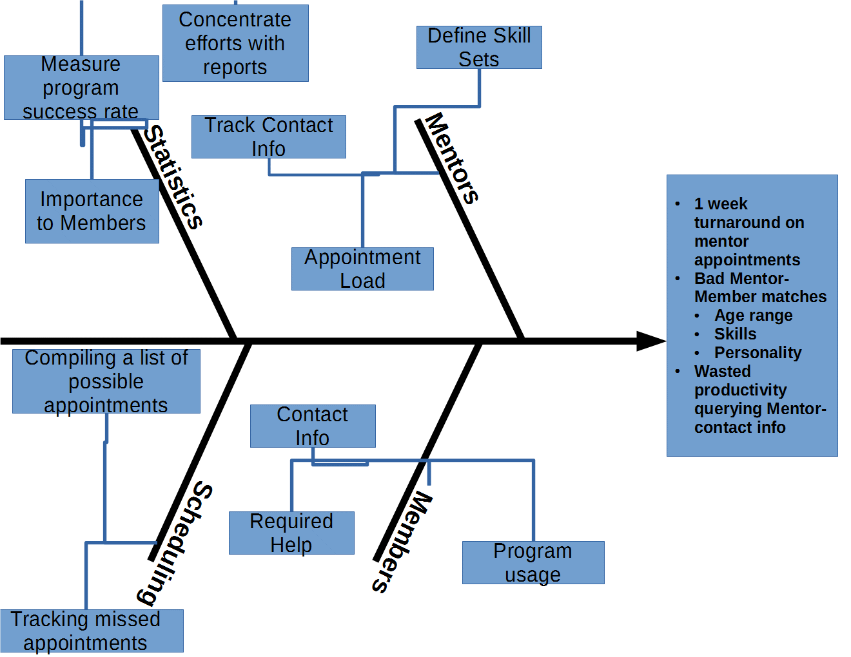**Cause and Effect Diagram**

**Swim Lane Diagram**

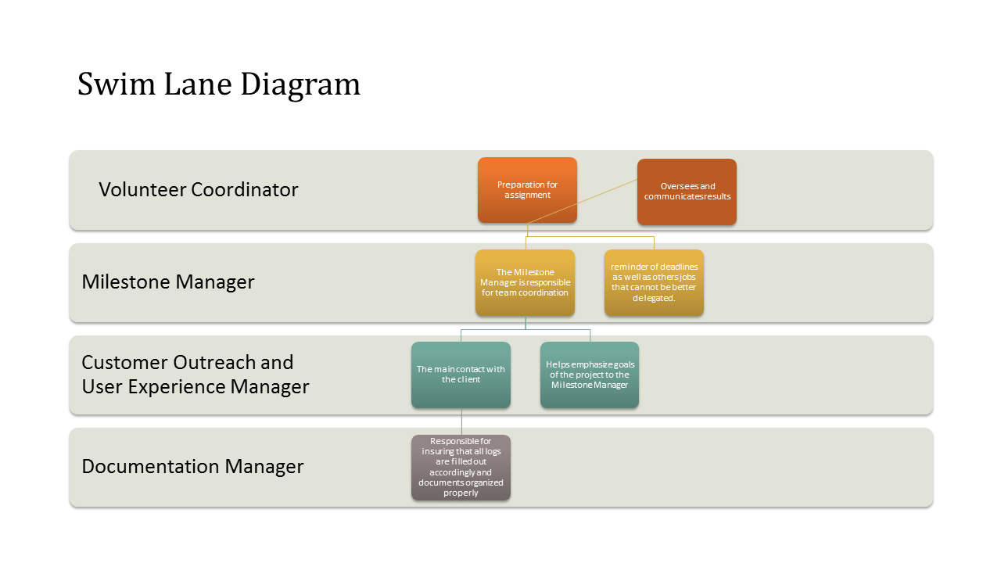

**Work Flow Diagram**

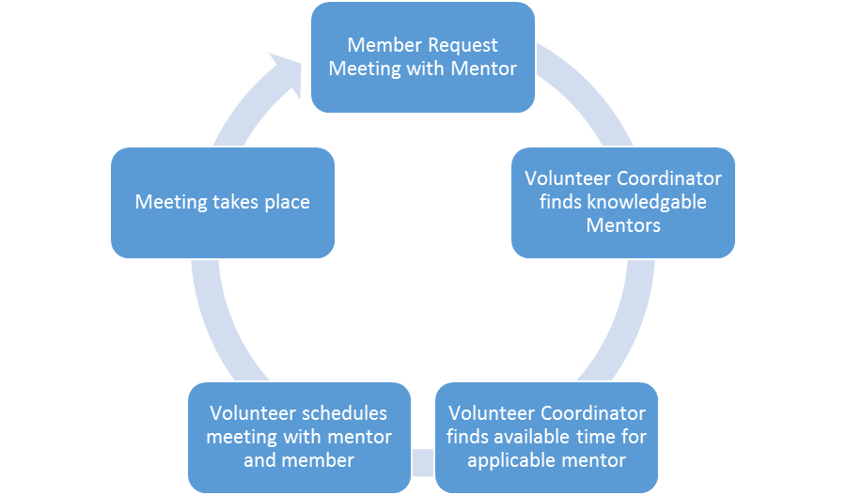

**Organizational Chart**

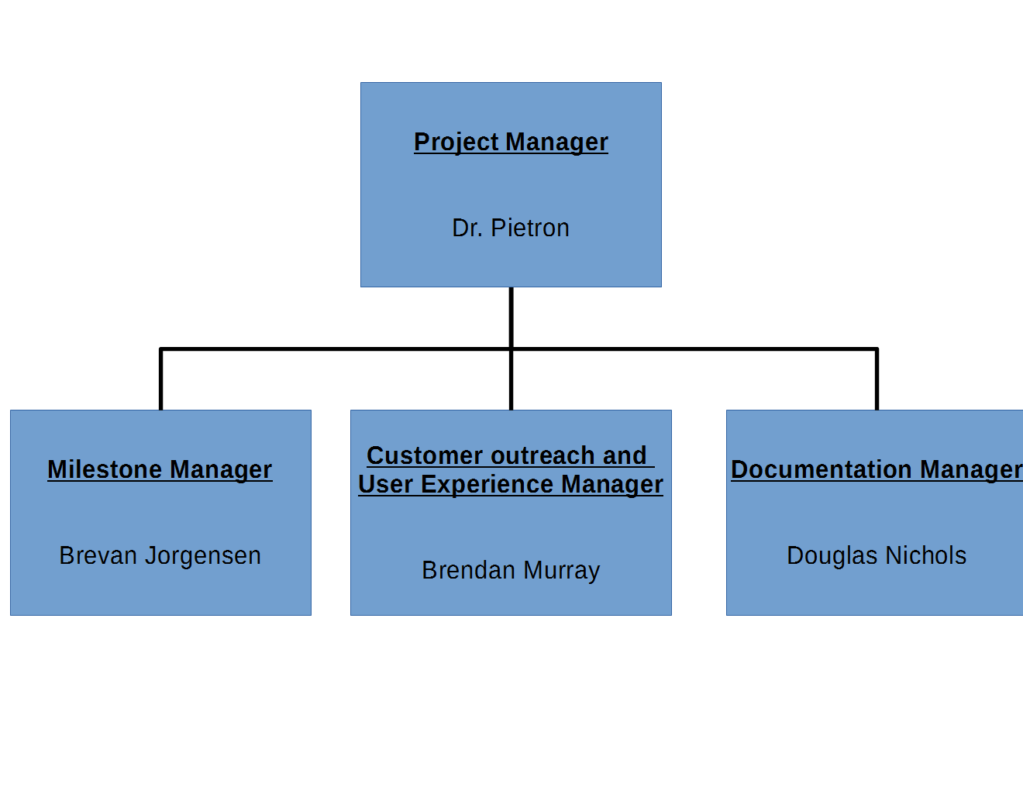



**Appendix D: Project Management Document**

(Attached as separate file)



**Appendix E: Economic Feasibility Analysis**

(Attached as separate file)